**CV FORMAT – KEFRI SCIENTISTS**

**PICTURE**

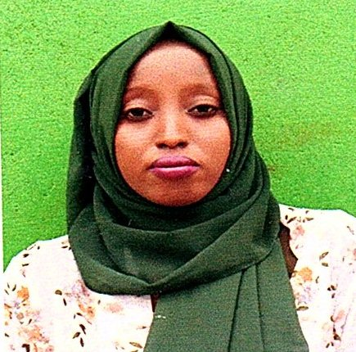 **RESEARCHERID:**

**SCOPUS ID:**

**ORCHID:** **0000-0002-5171-1078**

**Position:** Assistant Research Scientist (Natural Resource Management).

1. **PERSONAL INFORMATION** 
   1. NAME Rufo Gano Jillo
   2. ADDRESS P.O Box 87-90137, Kibwezi.
   3. PHONE 0714719501
   4. EMAIL ADDRESS [rufogano2015@gmail.com](mailto:rufogano2015@gmail.com) or rjillo@kefri.org
   5. NATIONALITY Kenyan
   6. GENDER Female
2. **QUALIFICATIONS** 
   1. Academic Qualifications

2015-2019: Bachelor of Environmental Studies-(Environmental Planning and Management) , University of Kabianga, Kericho, Kenya.

Qualifications: Second Class Upper Division

* 1. Key Competencies

|  |  |  |
| --- | --- | --- |
| * Mapping and Visualization * Technical Knowledge in: -ArcGIS, QGIS,AutoCAD and SPSS * Environmental Impact Assessment * Analysis and risk assessment * Remote Sensing and Analysis * Geospatial analysis. |  | * Data Collection and Research * Environmental Audits * Office administration skills * Cross-Functional Team Collaboration &Leadership * Ms. Office Proficiency |

* 1. Other Courses
* **Oct to Dec 2019:** Regional Centre for Mapping of Resources for Development
  + - Basic and Advanced GIS Training Course.
* **April to May 2019:** University of Kabianga- Geo-Spatial Database Development **and Management** (Training Course)
* **Jan to March 2015:** Brains view Computer College
  + - Certificate in computer studies-(**Distinction)**

1. **EMPLOYMENT HISTORY**

**Dec 2020 –To Date Kenya Forestry Research Institute | Assistant Research Scientist(Natural Resource Management)**

|  |  |
| --- | --- |
| **Sept 2020-Nov 2020**  **Sept 2019 – To Sept 2020**  **July 2018-Sept 2018**  **Nov 2017** | **Ministry of Transport, Infrastructure, Housing, Urban Development and Public Works | Internship**  **County Government of Marsabit -Department of Land, Energy and Physical Planning | Internship**  **County Government of Marsabit -Department of Land, Energy and Physical Planning | Attachee**  **International livestock Research Institute |Enumerator** |

1. **ADMINSTRATIVE RESPONSIBILITY**
2. **PUBLICATIONS** 
   1. Journal papers
   2. Books
   3. Book Chapter
   4. Technical Notes /Protocols/Guidelines
   5. Policy Briefs
3. **RESEARCH** 
   1. **Completed**
   2. **Ongoing research**
   3. Mentorship and supervision
4. **INNOVATIONS AND PATENTS (Intellectual Property)**
5. **CONFERENCES/SEMINARS/WORKSHOPS** 
   1. Presentation of Papers at Academic and Professional Conferences

* **M. M. Okeyo, B. Kamondo, J. Njehu, Rufo. G. J and A. O. Mosongo**

Validating viability of Melia volkensii seeds stored as extracted seeds or nuts for production of high quality germplasm in domestication and conservation of dryland tree species

A paper to be presented at the Xv World Forestry Congress (WFC 2021) conference from 2nd to 6th May, 2022 at Coex, Seoul, Republic of Korea.

* **M. M. Okeyo1, J. M. Kituku2, Rufo. G. J3 and J. M. Kimiri4**

Experience of on-farm commercial forestry in drylands: A case study of farmers’ experiences in Kibwezi, Makueni County

A paper presented during the commercial forestry investment conference to be held at KEFRI, KENYA from 23rd to 26th November, 2021

* **By, Rufo Gano Jillo\****a***,** *M., Oscar Kisakab and George Omondi**a*

Spatial analysis of shifts in livestock routes and density in response to land-use change in Marsabit

County, Kenya: Chuka University 6th International Research Conference. Theme; Leveraging Enterpreneurial Research Education for sustainable Development.

* 1. Participation in Workshops/Conferences

* 1. Convening/Coordinating Conferences

1. **PROFESSIONAL ENGAGMENT**
   1. Training

* **October to Nov 2021**:Forestry Addressing Climate Change and sustainable development for the belt and Road initiative organized by National Academy of forestry and grassland administration of china
* **May 2021:** Restoring African Degraded Landscapes (Redeal) Soil Carbon Monitoring Training Workshop(Organized by University of Kabianga
  1. Consultancies
  2. Collaboration with external organizations

1. **EXTERNAL AND INTERNAL RESEARCH GRANTS**

Include research grants won

1. **LOCAL, REGIONAL & INTERNATIONAL APPOINTMENTS** 
   1. Local
   2. Regional
   3. International
2. **AWARDS AND RECOGNITION**
3. **CONTRIBUTION TO KEFRIs ADVANCEMENT**
4. **MEMBERSHIP TO PROFESSIONAL BODIES**

* The Kenya Institute of Planners Membership No.0975G (Environmental and Climate Change Chapter

1. **REFEREES**

**1. Buno Woche,** Geospatial Analyst officer Marsabit County.Email:bunogache@gmail.com

**2**. **Joseph Hitimana,**Dean School of Natural Resource and Environmental Management**,** University of Kabianga.

Email: josephhitimana@kabianga.ac.ke