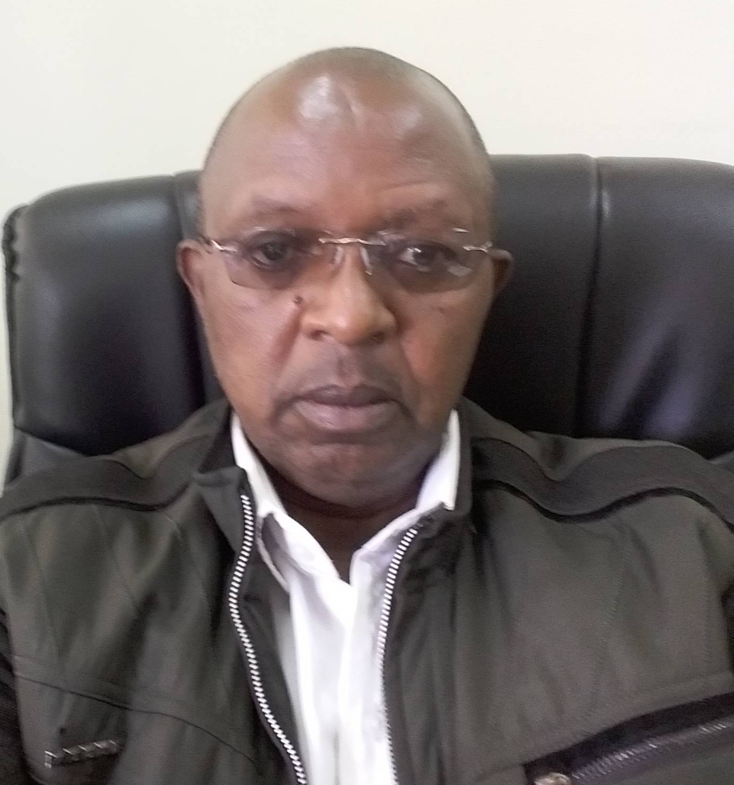
CV DR. JAMES M. KIMONDO – CHIEF RESEARCH SCIENTIST
Position: –Deputy Director Forest
Productivity & Improvement
- PERSONAL INFORMATION
  - NAME: James M. Kimondo
  - ADDRESS: Box 35381-00200 Nairobi
  - PHONE: +254 722 630 487/ 732 640 124
  - EMAIL ADDRESS: jmkimondo@kefri.org / jmkimondo59@yahoo.co.uk
  - NATIONALITY: Kenyan
  - GENDER: Male

- QUALIFICATIONS
  - Academic Qualifications: PhD Dryland Agroforestry
  - Key Competencies: Bio Statistics/Silviculture/ Forest Management
  - Other Courses: Forest Resource Assessment

- EMPLOYMENT HISTORY
Employed in May 1983, as an Assistant Conservator of Forests and posted to Kenya Agricultural Research Institute (KARI), Forest Research Department (FRD) immediately. In July 1983, I was seconded to KARI where I worked until June 1986, when the FRD translated into the current KEFRI. I have grown through the ranks until my current position as a Chief Research Scientist which I attained in 2010 after obtaining my PhD.
- ADMINSTRATIVE RESPONSIBILITY
Over the years in KEFRI I have been in charge of a number of Centres overseeing the research as well as development agenda therein. Significant among these was the initiation of the large scale planting of an indigenous tree species – Melia volkensii. This went on to attract a lot of attention among other research both local and internationals working in the country eventually leading to the funding of an excursion in the country initially by the Belgium Technical Cooperation (BTC) to identify the superior trees in the natural range of the species. The activity was further supported by the Japanese International Agency (JICA) where not only did they extend the exploration, but also supported the establishment of orchards which are already bearing superior germplasm for planting in the dry areas, thereby taking commercial forestry to the drylands.
- PUBLICATIONS
  - Journal papers
Kimondo JM. 2015. Using data to tackle climate change. In the July Issue of the African Technopolitan – A magazine of ACTS pp86-87.

Kimondo, JM, Agea JG, Okia CA, Abohassan, RAA, Ndeunyema, ETNN,Woiso DA, Teklehaimanot Z and Mulatya J. 2012. Physiochemical and nutritional characterization of Vitex payos (Lour.) Merr. (Verbenaceae): An indigenous fruit tree of Eastern Africa. Journ Hort. For4(10): 161-168.

Katumbi NM, Kinyanjui MJ, Kimondo JM and Mware MJ (2017) Biomass Energy Resource of the Highland Bamboo (Yushania alpina) and Its Potential for Sustainable Exploitation in Southern Aberdares Forest. Journal of Sustainable Bioenergy Systems , 7, 85-97. https://doi.org/10.4236/jsbs.2017.73007
Kimondo J.M., Oduor N. M., Kamondo B.M. and Ochieng D.O. (2016). (eds). Commercialization of Non-Wood Forest Products through linking to SMEs and Community Groups. KEFRI, Kenya. Pp 30
Kimondo JM, Agea JG, Okia CA, Woiso DA, Abohassan RAA, Mulatya J and Teklehaimanot Z. 2014. Distribution and regeneration status of Vitex payos (Lour.) Merr. in Kenyan drylands. Journal of Horticulture and Forestry 6(9): 81-91
Woiso DA, Shemdoe RS, Agea JG, Okia CA, Kimondo JM, Teklehaimanot, Z and Mwang’ingo P. 2014. Regeneration, soils and associates of three subspecies of Sclerocarya birrea in Tanzania. Agricultural Journal 9(4): 173-182

Gathara M, Makenzi P, Kimondo JM and Muturi GM. 2014. Prediction of Osyris lanceolata (Hochst. & Steud.) site suitability using indicator plant species and edaphic factors in humid highland and dry lowland forests in Kenya. Journal of Horticulture and Forestry. 6(11): 99-106

Woiso DA, Agea JA, Okia, CA, Kimondo, JM, Abdallah, JM, Shemdoe, RS, Mwang’ingo, P. and Teklehaimanot Z. 2014. Comparison of the subspecies of Sclerocarya birrea by sex and environment. Tanzania Journal of Forestry and Nature Conservation, 83(2):44-68. Tanzania Journal of Forestry and Nature Conservation, 83(2):44-68.

Okia CA, Agea JG, Kwetegyeka J, Okiror P, Kimondo JM, Teklehaimanot Z and Obua J. 2013. Nutritional value of commonly consumed desert date tree products. African Crop Science Journal, 21(3): 657 – 667.

Okia, CA, Kwetegyeka J, Okiror P, Kimondo JM, Teklehaimanot Z and Obua J. 2013. Physico-chemical characteristics and fatty acid profile of desert date kernel oil. African Crop Science Journal, 21(3):723- 734

Abohassan, RAA, Okia, CA, Agea, JC, Kimondo, JM and McDonald, MC 2012. Perennial Biomass production in Arid Mangrove Systems on the Red Sea Coast of Saudi Arabia. Environmental Research Journal 6(1): 22-31.

Gathara M, Makenzi P, Kimondo JM and Muturi GM. 2014, Prediction of Osyris lanceolata (Hochst. & Steud.) site suitability using indicator plant species and edaphic factors in humid highland and dry lowland forests in Kenya. Journal of Horticulture and Forestry. 6(11), 99-106

Agea, JG, Kimondo, JM, Okia, CA, Abohassan, RAA, Obua, J, Hall, J and Teklehaimanot, Z. 2011. Contribution of Wild and Semi Wild Food Plants to Overall Household Diet in Buyoro-Kitara Kingdom, Uganda. Agricultural Journal 6(4): 134-144.

Okia, CA, Agea, JG, Kimondo, JM, Abohassan, RAA, Okiror, P, Obua, J and Teklehaimanot, Z. 2011. Use and management of Balanites aegyptiaca in drylands of Uganda. Research Journal of Biological Sciences. 6(1):15-24.

Kimondo, JM, Okia, CA, Agea, JG, Abohassan, RAA, Mulatya, J & Teklehaimanot, Z. 2011. Estimating fruit yield from Vitex payos (Lour) Merr. in semi arid Eastern province of Kenya: application of allometric equations. Research Journal of Applied Sciences 6(3): 153-162.

Okia, CA, Agea, JG, Kimondo, JM, Abohassan, RAA, Obua, JA & Teklehaimanot, Z. 2011. Harvesting and processing of Balanites aegyptiaca leaves and fruits for local consumption by rural communities in Uganda. Journal of Food Technology 9(2): 83-90.

Agea, JG, Okia, CA, Abohassan, RAA, Kimondo, JM, Obua, J, Hall, J. & Teklehaimanot, Z. 2011. Wild and Semi Wild Food Plants of Bunyoro-Kitara Kingdom of Uganda: Growth Forms, Collection Niches, Parts Consumed, Consumption Patterns, Main Gatherers and Consumers. Environmental Research Journal 5(2): 74-86.

Kimondo, JM, Agea, JG, Okia, CA, Abohassan, RAA, Mulatya, J & Teklehaimanot, Z. 2010. Vitex payos (Lour.) Merr fruit trees in drylands areas of Eastern Kenya: Uses, Marketing and Management. Botany Research Journal 3(1–4):14–21

Agea, JG, Okia, CA, Abohassan, RAA, Kimondo, JM, Tumwebaze, SB, Ndemere, P, Buyinza, P, & Obua,J.2010. The impacts of land use and forest activities on Tree species composition and structure on the edges of Budongo Forest Reserve, Uganda. Botany Research Journal 3(1-4):7-13

  - Book Chapter
UNEP 2019: Technical report on Sustainability of sugarcane bagasse briquettes and charcoal value chains in Kenya: results and recommendations from implementation of the Global Bioenergy Partnership Indicators
  - Technical Notes /Protocols/Guidelines
Hyvönen P, Haakana H, Muchiri MN, Muga M, Bekuta BK, Kimondo JM, Mbithi DM, Ngugi J, Nduati PN, Karega S, Kinyanjui M and Ojuang F. 2016 (compilers). Field Manual for Tree Volume and Biomass Modelling. Improving Capacity in Forest Resources Assessment in Kenya (IC-FRA). Nairobi. http://kefri.org/wp-content/uploads/PDF/Publications/FM_Biomass.pdf
Kimondo J.M., Oduor N. M., Kamondo B.M. and Ochieng D.O. (2016). (eds). Commercialization of Non-Wood Forest Products through linking to SMEs and Community Groups. KEFRI, Kenya. 30Pp

- RESEARCH
  - Completed
UNEP 2019: Technical report on Sustainability of sugarcane bagasse briquettes and charcoal value chains in Kenya: results and recommendations from implementation of the Global Bioenergy Partnership Indicators

Ongugo PO, Langat D, Oeba VO, Kimondo JM, Owuor B, Njuguna J, Okwaro G and Russell AJM. 2014. A review of Kenya’s national policies relevant to climate change adaptation and mitigation: Insights from Mount Elgon. Working Paper 155. Bogor, Indonesia: CIFOR. Available online at http://www.academicjournals.org/JHF DOI: 10.5897/JHF12.010 ISSN 2006-9782 ©2012 Academic Journals Full Length Research Paper

  - Ongoing research
Integrated collaborative research on climate change, water resources and food security in upper Ewaso Ngiro river basin for sustainable management and enhanced ecosystem health funded by NRF in 2017/2018 for 3 years. Implementation by KEFRI in collaboration with University of Nairobi, National Museums of Kenya and Dedan Kimathi University of Technology

  - Mentorship and supervision
- Supervision of Monicah Ndirangu; MSc Karatina University Registration N223/5121P/13. Thesis Title: Biomass energy potential of the highland bamboo (Yushania alpina) and possibility for sustainable exploitation in southern Aberdares forest. 2018
- Supervision of Mary Gathara: MSc Egerton University. Thesis Title: Biophysical environmental factors influencing the distribution and yield of Osyris lanceolata (hochst&steud). Case study of Gachuthi and Kibwezi forests, Kenya. ﻿2015

- Supervised several Final Year Students in Karatina University in the School of Natural Sciences

- Have been an External Examiner for MSc thesis, for the School of Natural Studies, Kenyatta University since 2018.

- CONFERENCES/SEMINARS/WORKSHOPS
  - Presentation of Papers at Academic and Professional Conferences
Kimondo,JM Njuguna, JW. Ng’ang’a, J. Karuno, O and Orao B. 2020. Growth performance of Casuarina junghuhniana provenances in two sites in Kenya. In: Haruthaithanasan M., Pinyopusarerk K., Nicodemus A., Bush D. and Thomson L. (eds.) 2020.Casuarinas for green economy and environmental sustainability. Proceedings of the Sixth International Casuarina Workshop held at Krabi, Thailand, 21-25 October 2019. Kasetsart Agricultural and Agro-Industrial Product Improvement Institute, Kasetsart University: Bangkok. 162-170.

P.C. Ogutu, M.O. Muga, R. Pretorius, C. Obonyo, V.Yegon, V.Oriwo,,E.Kitheka, N.Oduor, J.Githiomi and J.Kimondo.Piloting Commercial Production of Charcoal Briquettes from Sugarcane Bagasse in Homa-Bay County. A paper presented during the 5th KEFRI Conference at KEFRI Muguga, 17-19, April 2018

E. Kitheka, C.Ogutu, N. Oduor, M.Muga, V. Oriwo, C.Ingutia, J. Kimondo and J.Githiomi. Piloting biomass energy audit for energy conservation in Homa-Bay County, Kenya. A paper presented during the 5th KEFRI Conference at KEFRI Muguga, 17-19, April 2018

Oduor, N., E. Kitheka, J. Kimondo J. ,Kimwemwe, , N.Hussein, and G.Omedo (2018). Improved Earth and Casamance kilns for enhanced efficiency and environmental conservation A paper presented at the 5th KEFRI Scientific Conference held at KEFRI Hqs; 17th – 19th April 2018.

Omenda, T.O., Kimondo J.M. and Muchiri M.N. 1998. Establishment of Natural Regeneration Management Trial of Cupressus lusitanica in Londiani - Kenya. In Proceedings, Modelling the Growth of Tree plantation and Agroforestry Systems in South and East Africa. The University of Joensuu, Faculty of Forestry Technical Note No.80.

  - Participation in Workshops/Conferences
Participated in the Regional Universities Forum for Capacity Building in Agriculture (RUFORUM) Workshop in Kampala, Uganda April 2018.
  - Convening/Coordinating Conferences
Kamondo, B.M., Kimondo, J.M., Mulatya, J.M. and Muturi, G.M. (eds) 2004. Research and Technology Development of Mukau (Melia volkensii Gurke). Proceedings of the 1stNational Workshop held at Kitui Regional Research Centre 16-19 Nov 2004. 73p.
- PROFESSIONAL ENGAGMENT
  - Training
Taught on part time basis in Karatina University taking BSc Forestry Class in Silviculture and Tree management; and Forest Biometrics for 3 years
Taught MSc Class Dryland Tree Management at Karatina Unversity
  - Consultancies
Kimondo et al. (2017). A baseline study on Business Incubation for forest and farm enterprises in Kenya. Report prepared for Farm and Forestry Facility of the FAO, Nairobi.
Kimondo JM, Kiama S and Kagombe JK. 2015. Cherangani Hills Forest Strategic Ecosystem Management Plan 2015 – 2040. Kenya Forest Service, Nairobi.

Kagombe JK, Kimondo JM and Kiama S. 2015. North and South Nandi Forests Strategic Ecosystem Management Plan 2015 – 2040. Kenya Forest Service, Nairobi.

Kiama S, Kagombe JK, Kimondo JM and 2015. Kakamega Forest Strategic Ecosystem Management Plan 2015-2040. Kenya Forest Service, Nairobi.

- EXTERNAL AND INTERNAL RESEARCH GRANTS
National Research Funds – Granted Ksh 19.9m for a three year research together with Dedan Kimathi University, University of Nairobi and the National Museum of Kenya

- LOCAL, REGIONAL & INTERNATIONAL APPOINTMENTS
- Member of the Multi-agency team for mapping, verification and valuation of mature/over mature forest plantations by Ministry of Forestry and Environment
- Member of the Multi Agency Oversight Team – in charge of oversighting the inventory and sale of 5000 ha of mature and overmature plantations in the country.

- AWARDS AND RECOGNITION
Commendation Letter by the Cabinet Secretary for delivering a comprehensive report of the Mature and Over mature Forest Plantations in Kenya.

Commendation for reactivating tree nurseries in all the State Houses and State Lodges in the country for improved production of seedlings
- CONTRIBUTION TO KEFRIs ADVANCEMENT
- Have been involved in preparation of ALL KEFRI Strategic Plans since its inception in 1986.

- Initiated the planting of Melia volkensii as a plantation species on a large scale in 2001
- MEMBERSHIP TO PROFESSIONAL BODIES
Full Member of the Forestry Society of Kenya,
- REFEREES
Dr. Paul Konuche
Former CEO, KEFRI

Dr. Joshua Cheboiwo
CEO/Director KEFRI

